**Week 2**

**Exercise 1: Setting Up Junit**

Created a new project in intellij, added dependency in pom.xml file and created a test class

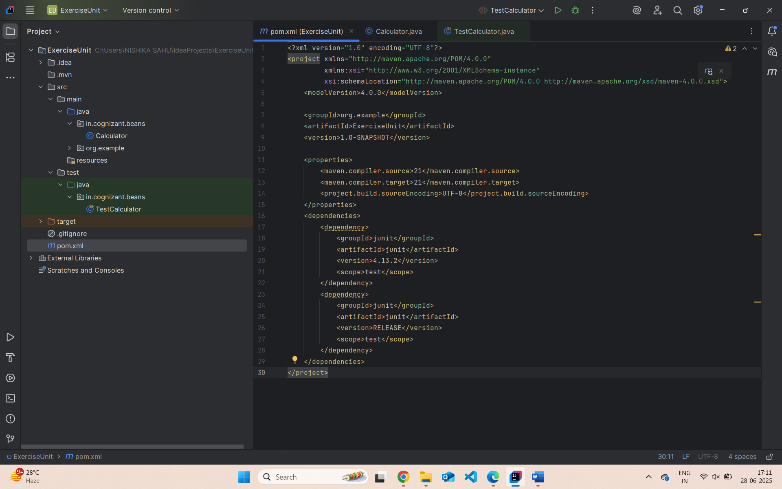

**Exercise 3: Assertions in JUnit**

Scenario: You need to use different assertions in JUnit to validate your test results.

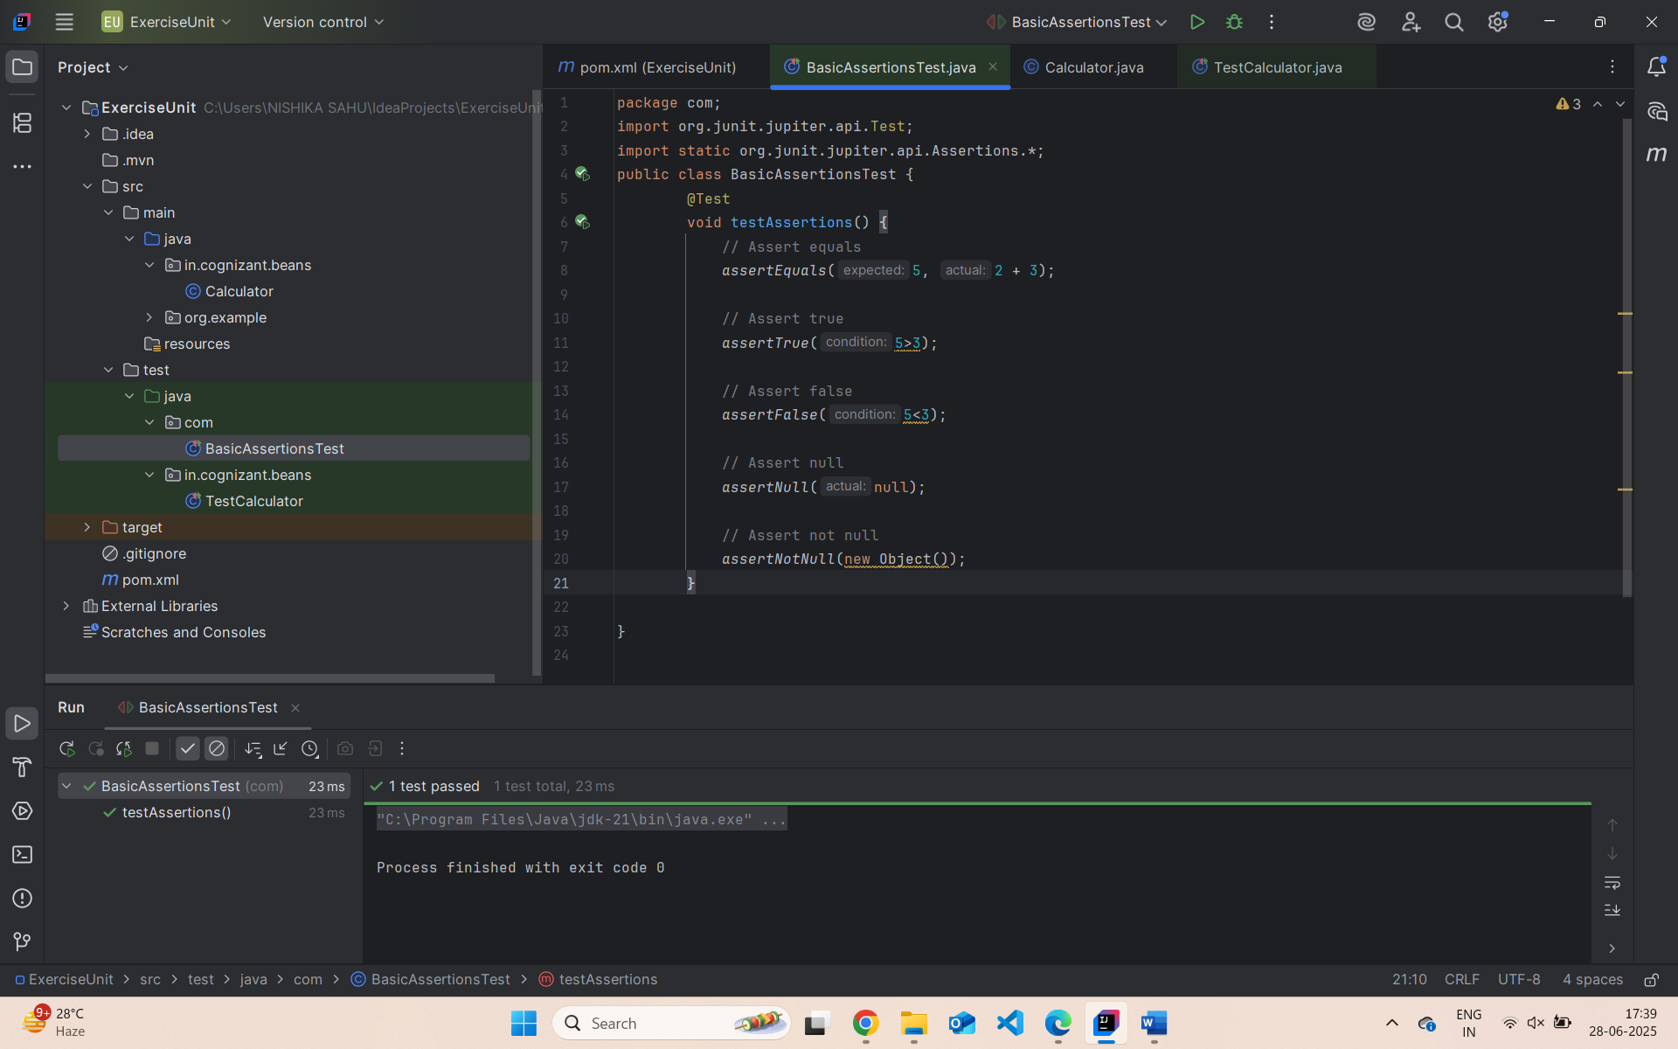

**Exercise 4:**

Arrange-Act-Assert (AAA) Pattern, Test Fixtures, Setup and Teardown Methods in Junit

**Code:**

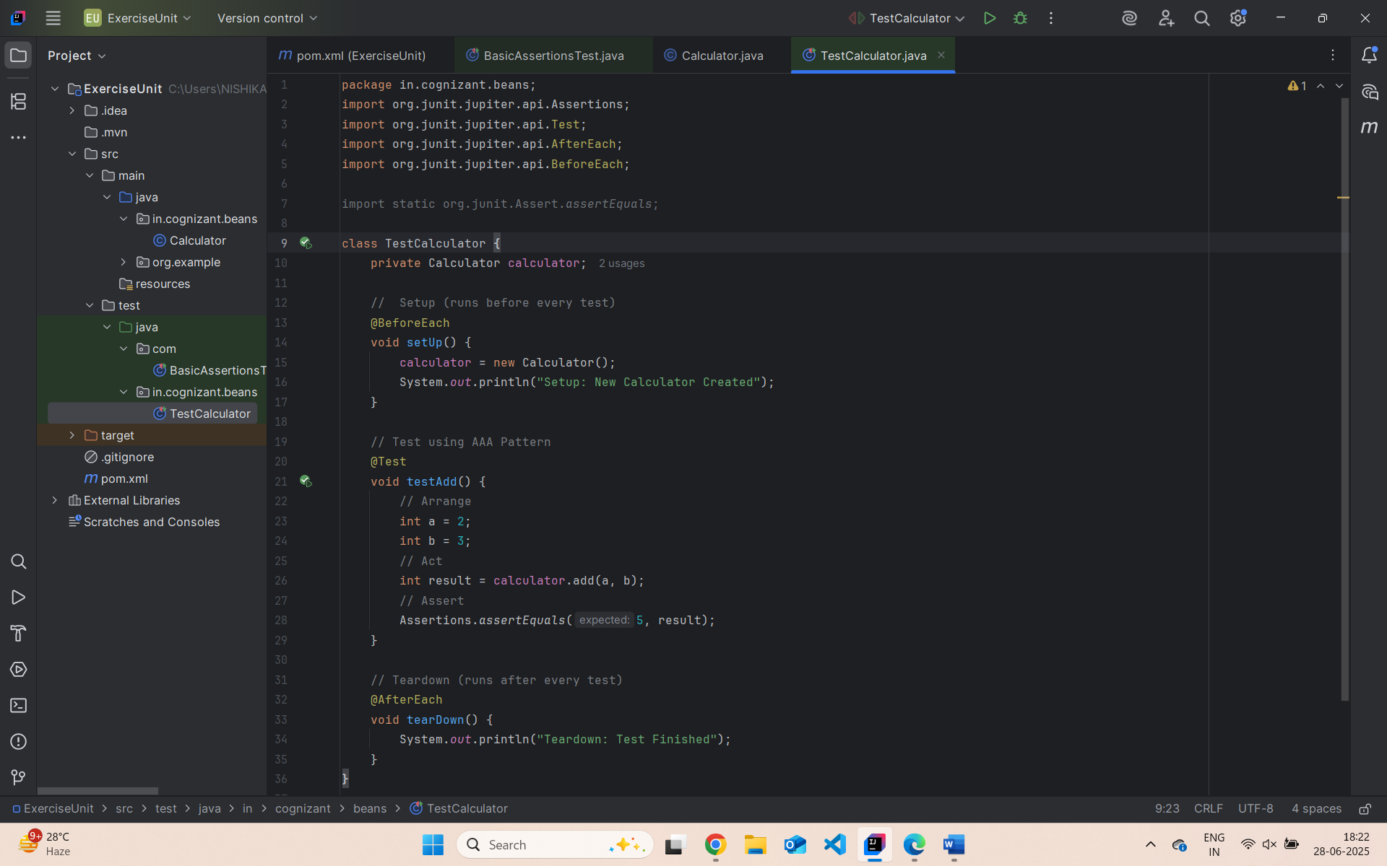

**Output :**

